Mathematics
State Exam Review Packet
- GOOD LUCK!!! (Don`t Fail it! Your teachers worked so hard to prepare you for this exam)
- The entire exam takes three days to complete.
- Day 1: Multiple Choice (30 Questions)
- Day 2: Multiply Choice (30 Questions)
- Day 3: Short and Extended Responses (10 Questions)
- Total Questions: 70 Questions

Name/Class
___________________

Section 1-Fractions
I. Adding and Subtracting Fractions
When Adding and Subtracting Fractions, you must:
- Find the Lowest Common Denominator (LCD)
- Rename the fractions by having the LCD
- Add or subtract the numerators
- Simplify (If needed)
(If they have the same denominator already, just add or subtract)
***Sometimes when you add or subtract, you end up with an improper fraction. DON`T PANIC! You can turn it into a mixed number

(Adding Fractions)  Example: 1/2 + 1/3  When solving this fraction, you need to find the LCD.  1. Find the LCD. For this problem, the LCD is 6.  2. So you do: 1/2×3/3 and 1/3×2/2 which gets you 3/6 + 2/6  3. Now you add! Giving you 5/6 as your answer. | (Subtracting Fractions)  Example: 1/2 - 1/3  When solving this fraction, you need to find the LCD.  1. Find the LCD. For this problem, the LCD is 6.  2. So you do: 1/2×3/3 and 1/3×2/2 which gets you 3/6 - 2/6  3. Now you subtract! Giving you 1/6 as your answer.

II. Multiplying and Dividing Fractions
- When multiply fractions, you just multiply the fractions. Multiply numerator by numerator and denominator by denominator. You DON`T need a common denominator. IF the answer needs to be simplified, simplify it.
- When dividing fractions, you do Keep Change Flip (KCF). KCP is ONLY used for dividing fractions. You keep the first fraction, you then change the division sign into a multiplication sign and the flip the second fraction.

(Multiplying Fractions)  Example: 2/5 × 1/3  1. All you need to do is multiply numerator by numerator and denominator by denominator.  2. So you do 2×1 (numerator) and 5×3 (denominator) which gives you 2 and 15.  3. So your answer is 2/15 | (Dividing Fractions)  Example: 7/8÷1/2  1. Use KCF. So you keep the first fraction (7/8), switch the sign (÷), and flip the second fraction (1/2).  2. After you do KCF, it will look like this: 7/8×2/1. Now when multiplying fractions, you just multiply. So you do 7×2 and 8×1 giving you 14 and 8.  3. So your final answer is 14/8. WAIT! We are not done! This is an improper fraction! You need to turn it into a mixed number.  You just divide 14 by 8 giving you 1 and a remainder. The remainder will be written as a fraction. So 14/8 can be written as 1 6/8.

III. Additional Information
- In order to find the LCD of fractions, you can multiply the current denominators together OR you list the multiples of the 2 numbers. When listing the multiples, you MUST find the smallest number they have in common. For example, the question you saw before, all you have to do was multiply the current denominators together. Or you can list the multiples. When you list it, you found out that, they both have a common factor of 6 and that`s the smallest number they both share.
2: 2, 4, 6,8,10
3: 3, 6, 9, 12, 15
- When you use KCF and your solution is an improper fraction, you divide the biggest number by the smallest number and you get a mixed number. For example, the example you saw before, the answer was 14/8 but then it changed into 1 6/8. 1 6/8 is known as a mixed number. However, sometimes the remainder isn`t in its simplified form, like 6/8. We can still simplify it. When 6/8 is simplified, you get ¾. So the answer in simplified form is 1 ¾.
- Sometimes when you subtract or add fractions, you get a negative fraction. Don`t worry. If it is a negative fraction, you just put a negative sign before the fraction or the mixed number.

IV. Simplify Diagonally
- When multiplying fractions, we can simplify the fractions and also simplify diagonally. This isn`t necessary, but it can make the number smaller and keep you from simplifying at the end
- Of course, to simplify diagonally, both numbers need to have a common factor.
- If both numbers don’t have a common factor, then you can`t simplify diagonally.

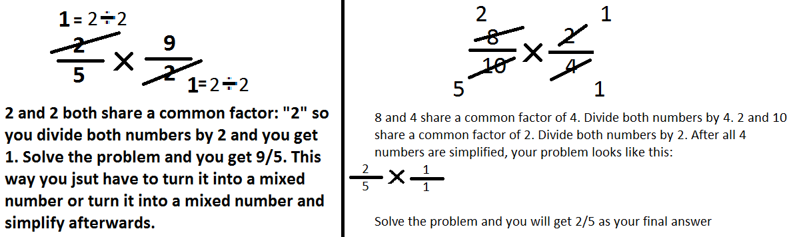

V. Equivalent Fractions
- Fractions that are EQUAL to each other
- To find an equivalent fraction, multiply the numerator and denominator by the same number

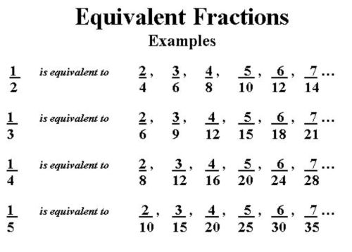

Section 2-Finding Percentage
I. Percent
- You can find percent of a number by using a ratio table or decimal conversion
- When using a ratio table to find the percent, you divide both the percent and reach a certain amount to find your percentage.
- When using decimal conversion, you turn the percentage into a decimal and multiply the decimal with the whole number.

II. Ration Table
- In this problem, someone was asked to find the 60% of 90. The student started at 100% and found his way to 60% by using addition, subtraction, multiplication, or division.

# | %
90  ÷2 | 100  ÷2
45  ÷5 | 50  ÷5
9 | 10  ×6
54  ×6 | 60

III. Decimal Conversion
- When finding the percentage of a number using decimal conversion. You turn the percentage to a decimal and take the number and multiply by the decimal.
60% of 90
60% 0.6
90
×0.6
540
000
54.0

IV. Finding Percentage for Fractions
- To find the percentage for fractions, you need to turn the fraction into a decimal, so you divide the numerator by the denominator OR you divide the denominator into numerator.
- After you found the decimal, move the decimal POINT two spaces to the right and add the percentage sign and you found your percentage.
- If the decimal is has a repeat bar, don`t worry. Just move the decimal point to the right two times and that will be your percentage.

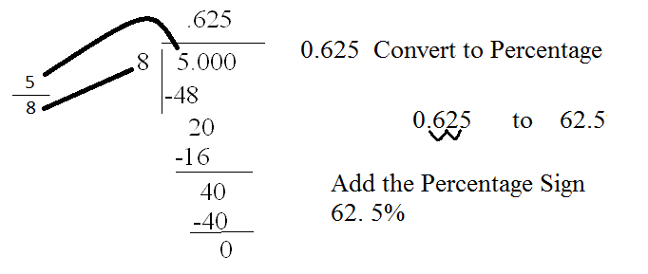

- OR multiply the decimal by 100

.625 × 100 = 62.5%
OR
.875 ×100 = 87.5%

Section 3-Integers and Order of Operations
I. Integers
- Are all whole numbers and their opposites

II. Addition Rules
- Adding positive and positive will ALWAYS be positive
- Adding negative and negative will ALWAYS be negative
- When adding positive and negative or negative and positive, use the sign of the larger number and subtract. Once subtracted, take the sign and put it in front of the solution

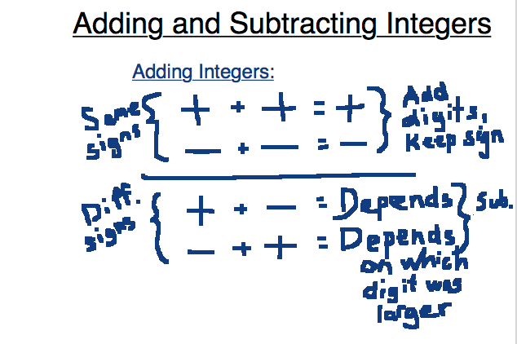

III. Subtraction Rules
- Use Keep Change Change to help you with subtracting integers
- Keep Change Change is when you take a problem where you keep the first number, change the sign and change the sign of the second number
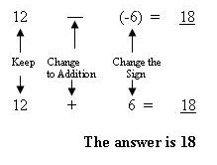

IV. Multiplication Rules
- Multiplying positive and positive will ALWAYS be positive
- Multiplying negative and negative will ALWAYS be negative
- Multiplying positive and negative or negative and positive will ALWAYS be negative
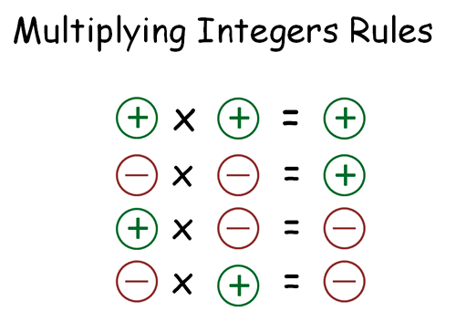
V. Division Rules
- Dividing positive and positive will ALWAYS be positive
- Dividing negative and negative will ALWAYS be negative
- Dividing positive and negative or negative and positive will ALWAYS be negative
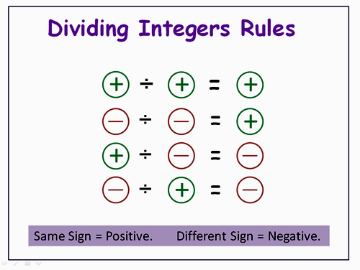

VI. Order of Operations
- When doing order of operation, YOU CAN NOT do it in any order you want.
- You must follow the rule
An Easier Way to Remember the Rule:
- Parentheses COME first. Second comes exponents. Third comes multiplication and division FROM LEFT TO RIGHT. Finally, come Addition and Subtraction from LEFT TO RIGHT!

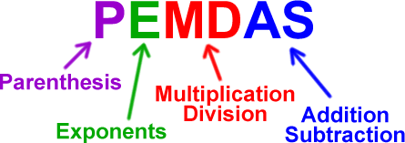

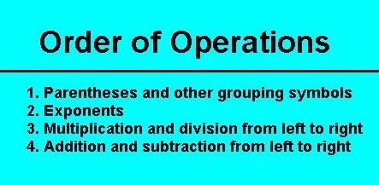

Examples

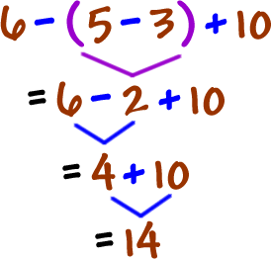 | 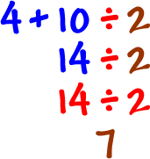
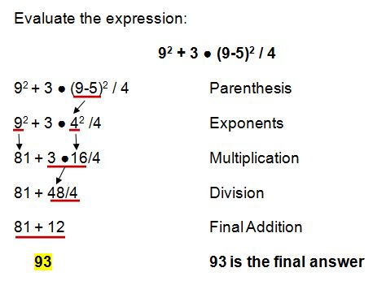 | 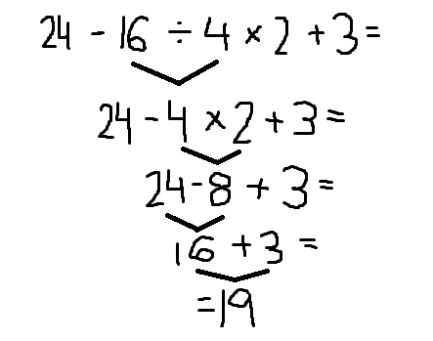

Section 4-Interests and Commission

I. Commission/Interest
- Commission- calculated based on a percent of a total price. People who earn commissions include realtors, sales persons, and talent agents.
- Usually commissions are expressed in percent.
- Using percentage, we can find how much money a person earns when he/she sells an item.

Example:
Norman earns 6% commission on each baseball uniform he sells. If each uniform costs $90, and he sells 21 uniforms to the Crestdale baseball team, how much will Norman earn?

Step 1: First, you need to find out how much money will he get by selling 21 uniforms that costs $90 each.
Step 2: Now, find 6% of 90. Your result should be 5.40
Step 3: So we know that for each uniform he sells, he gets $5.40 for commission
Step 4: Finally, he gets $5.40 when he sells ONE uniform. He sold 21 of them. So you take 5.4 and multiply by 21, giving you $113.40
Therefore, when Norman will earn $113.40 when he sells 21 uniforms to the baseball team

- To find the interest, you do the same.
Example:
Mr.Frangella wants to deposit $500 in the bank. Manny Goldfish bank had a 2% simple interest. He wanted to save this money 3 years, how much saving altogether will Mr.Frangella get after 3 years?

Step 1: First, find out the interest he earns in a year. Take 0.02 multiply by 500.
Step 2: You get $10 BUT HOLD ON! That`s one interest for ONE year
Step 3: To find it for three years, take 10 and multiply by 3 (Three Years interest). You get 30.
Step 4: Finally, take 500 and 30 and add them. And so, Mr. Frangella will have $530 in the bank at the end of the third year.

**You use percentage sometimes to find which coupon can save you more money.

Example:

Christian went to Best Buy to purchase a new Nintendo Wii gaming system. Since he often shops at Best Buy, he receives several coupons in the mail. Christian brought two different coupons with him to the store. One coupon read “15% off your total purchase”, while the other read “$25 off your total purchase”. The Wii originally costs $149.99.
WOW!!!
Come in today and get 15% off your purchase!
WOW!!
Come in today and receive $25 off your purchase!!!

For this example: you need to do two things.
- The first coupon, all you need to do is covert 15% into a decimal and multiply it with $149.99. Then, you take that amount and subtract it from $149.99.

15% 0.15
149.99 × 0.15 = 22.49
149.99-22.49 = 127.50

So Christian have to pay 127.50 if he use the first coupon

- The Second coupon is 25 dollars off, meaning that you subtract $25 from the original price.

149.99-25.00 = 124.99

So Christian have to pay 124.99 if he use the second coupon

- By doing this, you are able to tell which coupon will help Christian save more money. According to all the calculation, Coupon #2 helps him save more money. Seems like he just have to pay $124.99 to get the new Nintendo Wii gaming system.

Section 5-Transformation
I. Transformation
- Transformation is a change in location, size, or orientation of a figure
- There are 4 types of transformations. They are rotation, reflection, translation, and dilation.
- All transformations are congruent and similar EXCEPT Dilation is NOT congruent, they are similar.
- When a figure is transformed, the new image is labeled as “prime” (‘). SO if the figure ABCD is transformed, the image will be A’B’C’D’. If A’B’C’D’ (image) is transformed, the new image will be called double prime. A’B’C’D’ A”B”C”D”

II. Reflection
- When reflecting a figure, you usually have to find the line of symmetry. They are telling you to reflect the image.
- The figure can be reflected over the x-axis, y-axis, y=x, or y=-x.
- If for example, you were required to reflect a figure over x= 2. You draw the line of symmetry vertically. If you were required to reflect a figure over y=2, you draw a line of symmetry horizontally.
- No change in shape or size, only the orientation of the shape is changed

II. Rotation
- When a figure is rotated to a certain degree, it is called rotation
- A figure can be rotated 90 degrees clockwise/ counterclockwise, 180 degrees clockwise/ counterclockwise , or 270 degrees counterclockwise
- No change in shape or size, only the orientation and location of the shape is changed

III. Translation
- When a figure is moved up, down, left, or right by a certain number of unit, it is called translation
- A translation can be moved up, down, left of right
- No change in shape or size, only the location changes

IV. Dilation
- When a figure is enlarged or reduced by a certain amount, it is called dilation
- Dilation is represent in the scale factor of “K”
- No change in shape, but unlike other transformations, the SIZE changes

V. Reference for Transformation
- Here is a chart of rules for transformation. You can use the rule to draw the transformation or identify the transformation if told to do so.

Transformation | Rule
Reflection over x-axis | (x,y)(x,-y) | Horizontal  Line (x-axis)
Reflection over y-axis | (x,y)(-x,y) | Vertically Line  (y-axis)
Reflection over y=x | (x,y)(y,x) | Diagonally
Reflection over y= (-x) | (x,y)(-y,-x) | Diagonally
Rotation 90 degrees counterclockwise | (x,y)(-y,x) | Rotate 90 degrees  counterclockwise
Rotation 180 degrees | (x,y)(-x,-y) | Rotate 180 degrees
Rotation 90 clockwise/270 counterclockwise | (x,y)(y,-x) | Rotate 90 clockwise or 270 counterclockwise
Translation A units up | (x,y)(x,y+a) | Move the figure up by “A”
Translation A units down | (x,y)(x,y-a) | Move the figure down by “A”
Translation A units left | (x,y)(x-a,y) | Move the figure left by “A”
Translation A units right | (x,y)(x+a,y) | Move the figure right by “A”
Dilation of scale factor “K” | (x,y)(kx,ky) | Multiply both coordinates by “K”

Section 6-Angle Relationships
I. Vocabularies
- Acute Angle- an angle whose measure is less than 90 degrees
- Obtuse Angle- an angle whose measure is less than 180 degrees but greater than 90 degrees
- Straight Angle- an angle whose measure is exactly 180 degrees
- Right Angle- an angle whose measure is exactly 90 degrees
- Reflect Angle- an angle whose measure is greater than 180 degrees but less than 360 degrees
- Adjacent- angles next to each other
- “∠”- “Angle” (Symbol)
- m∠a- “Measure of angle a”
- Parallel Lines- two lines that NEVER intersects ⎢⎢(Symbol)
- Transversal Line(s)- line(s) that intersects two or more parallel lines
- Exterior Lines- angles OUTSIDE of parallel lines
- Interior Lines- angles INSIDE of parallel lines
- Congruent- same size and shape (same degree)
- Angle- A shape, formed by two lines or rays diverging from a common point (the vertex)

II. Angles
Vertical | - Formed by two intersecting lines  - Share the same vertex  -Opposite from each other  - Both angles are congruent | 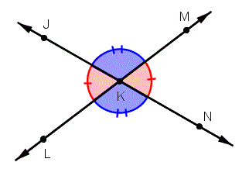
Supplementary | - Angles whose measure or sum adds up to 180 degrees | 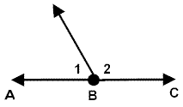
Complementary | - Angles whose measure or sum adds up to 90 degrees | 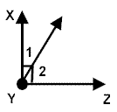
Corresponding | - One angle is exterior and the one angle is interior  - Have to be on the same side of the transversal line  - Congruent | 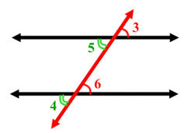
Alternate Interior | - Angles are inside of parallel lines (interior)  - Pairs of angles on opposite sides of the transversal line are congruent | 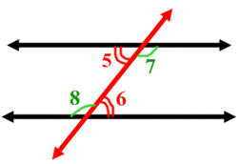
Alternate Exterior | - Angles are outside of parallel lines (exterior)  - Pairs of angles on opposite sides of the transversal line are congruent | 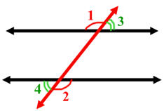

III. Additional Information
- Interior and Exterior Angles are NOT congruent
- When finding a missing angle, set up an equation. An equation comes in handy all the time!
- If an angle looks like a certain angle degree, it doesn`t necessary mean it is that degree. (FIGURE NOT DRAWN TO SCALE!). For example, if an angle looks like a 90 degree angle, it doesn`t necessary mean it`s 90 degree. It can be anything!

IV. Angle Sums of Polygons
- A triangle`s interior angles WILL always add up to 180 degrees
- A quadrilateral’s interior angles WILL always add up to 360 degrees
- A pentagon`s interior angles WILL always add up to 540 degrees
- A hexagon`s interior angles WILL always add up to 720 degrees
- A heptagon`s interior angles WILL always add up to 900 degrees

- You can use the expression: 180(N-2) where “N” represents the number of sides in the polygon.
- This expression comes in handy when you want to find the total degrees in a polygon.

Section 7-Functions and Scatter Plot
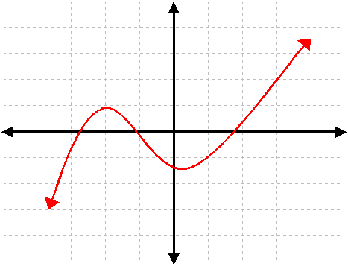 | 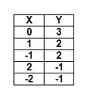
This graph is a function because it pass the vertical line test. As long as the vertical line test intersects ONLY one point, it is a function. No matter where you draw the line vertically and you ONLY hit one point, it’s a function | This is a function because one input ONLY has one output. Doesn`t matter if two inputs have the same output because the input only has that number as the output.
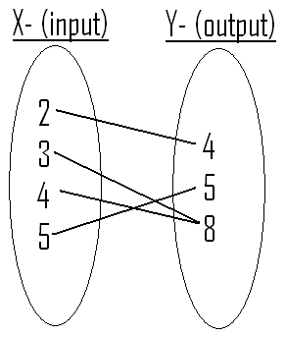 | 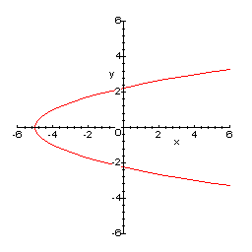
This s a function because ONE input has ONLY one output. A function must have input that have ONLY one output. It won`t matter if two inputs share the same output because that input can ONLY give you that output. | This is NOT A FUNCTION because when this graph was being tested by the vertical line test, it intersects TWO points. If that happens, it`s not a function. A FUNCTION can ONLY intersect one pint. Therefore, this is not a function.
I. Functions

Input (x) | Output (y)
0  +2 | 3  +4
2 | 7
4  +2 | 11  +4
6 | 15
Rate of Change is: Δy
Range
Delta
Δx
Domain
For this function, this is 4 divided by 2 which is 2. “2” is the coefficient. SO to start the equation is y=2x. But we are not done yet! 2 times any domain above doesn`t equal the output. Now we need to find the intercept! Now look at the input 0 and the output 3. Since anything times zero, is always zero, we know that something plus 0 equal 3. So now that we found the intercept, we can write the equation!
Equation: y= 2x+3
Now, if you need to find the y-value and they gave you 20 for the input, you can either add 4 to the previous output until you reach the output for 20. OR you can substitute the number 20 for “x”

y=2(20)+3 so the value of y is 43.

II. Scatter Plot
- A graph of plotted points that show the relationship between two sets of data.
- There are three types of correlations or associations. They are Positive Correlation, Negative Correlation and No Correlation
- Positive Correlation is when the x-value increases and the y-value increases as well
- Negative Correlation is when the x-value increases but the y-value decreases
- No Correlation is when the x-value increases but the y-value is not affected
- Remember; scatter plots need a line of best fit. A line that is drawn to have equal amount of points on top and the bottom of the line.

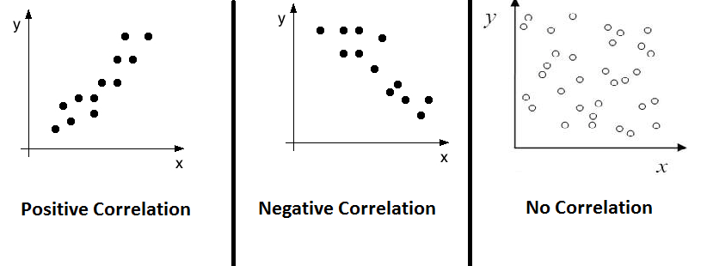
Section 8-Linear Functions (Slope and Y-Intercept)
I. Vocabularies
- Slope- tells you how steep a straight line is
- Y-Intercept- the point where the line intercept the y-axis
- Linear- a function that makes a straight line [Graphically] and has a constant rate of change [Arithmetically] (slope) and all linear functions follow the form of the general equation
(y=mx+b) [Algebraically]
- Direct Variation- mathematical relationship between two variables that can be expressed by an equation in which one variable is equal to a constant times the other
- Proportional- when two numbers are equal (same ratio)
- Parallel- two or more lines that are next to each other and never intercept one another
- Coefficient- the number before the variable (x) in an equation. (Also tells the slope)
- Relation- a set of ordered pairs. The set of ordered pairs in a relation can be shown using braces, tables, graphs, and mappings
- Function- a relation that has only one input and output
- Ordered Pairs- consists of one input and output value (x,y)
- Input (Independent)- The number or value that is entered or the number that substitutes the x-value
- Output (Dependent)- The number or value that comes out or the solution (y-value) of an equation. (The output is dependent. There is no output if there is no input)
- Rate of Change- also known as the slope. Change in the y-value over the x-value

II. Finding the Slope (Rate of Change)
Graphically | To find the Slope arithmetically, you use the rate of change formula where you take two inputs/outputs or ordered pairs and subtract them. Y-value over the X-value. | 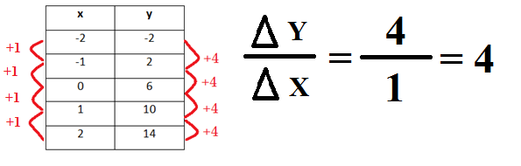
Arithmetically | To find the Slope graphically, you take two coordinates and use the rise and run or use the slope formula. | 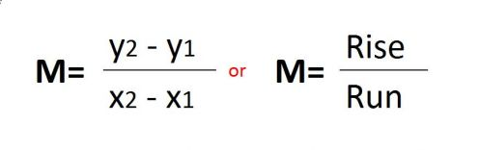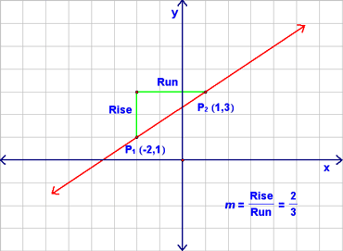
Algebraically | To find the slope algebraically, you look at the number before the x variable, in other words, the coefficient | 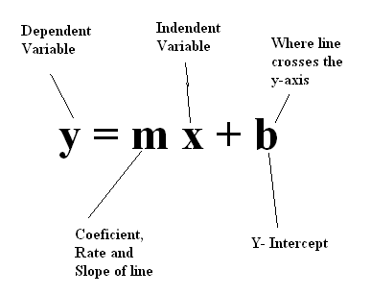

III. Finding the Y-Intercept
- To find the y-intercept, you need to find the point where the line intercepts the “y-axis” and where the x-value is zero.
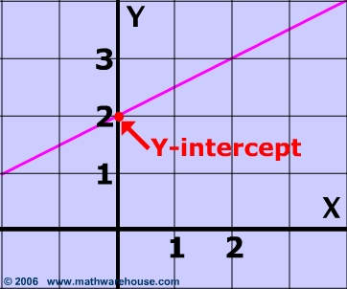 | 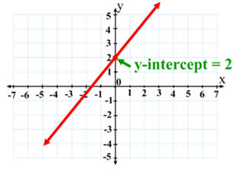

IV. Finding the Equation
When you are required to find the equation of a table or graph, you need to find the slope and y-intercept. Once you found the slope and the y-intercept, you have your equation. Use the rise/run formula and the y=mx+b equation to help you.

V. Identifying if Lines are Parallel
Graphically | Two lines are parallel if they have the same slope and are next to one another. (The will NEVER intercept) | 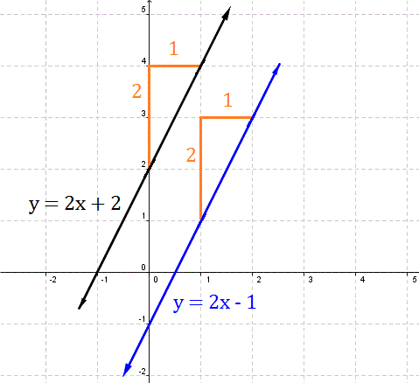
Arithmetically | To find out if two lines (relations) are parallel, they must have the same rate of change | 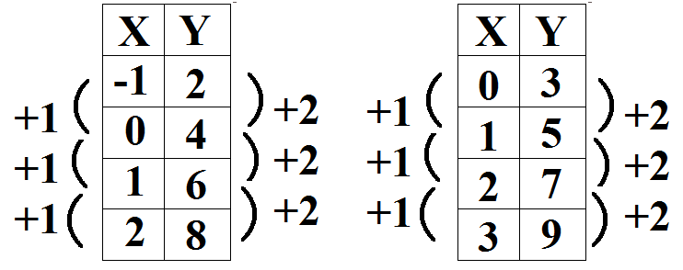
Algebraically | If the coefficient in the equations is the same, we will know that the lines will be parallel | 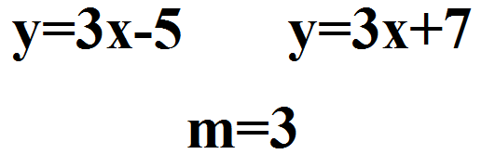

VI. Determining if a Relationship is Proportional

Graphically | The straight must pass the origin (0,0) | 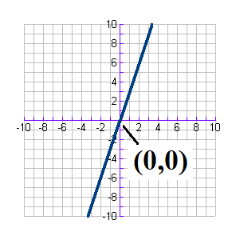
Arithmetically | When the input is multiply by a certain value, the output must be multiply by that certain value. For example, if the input is multiply by 3, the output must be multiply by 3 | 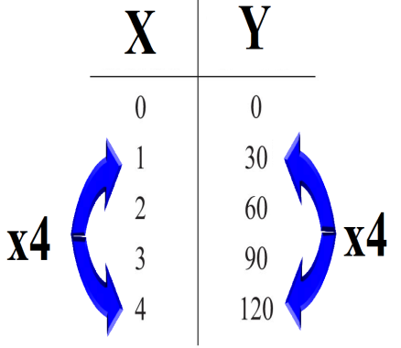
Algebraically  y=mx | The y-intercept has a value of zero. So the general equation for a relationship to be proportional is y=mx | y=10x  y=5x

Section 9-Equations and Volume of Three-Dimensional Figures
I. Like Terms
- Algebraic Expression- a phrase made up of variables and or numbers
- Term- is made up of a variable, coefficient, or both (constant) Separated by a positive or negative symbol
- Constant- is a term without a variable
- Like Terms- terms with the same exact same variable or variables raised to the same power
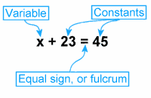

II. Combine like Terms
- When you come across an expression or equation that is long and you are required to simplify:
- First, you use distributive property (if necessary) to get rid of the parenthesis
- Next, look for like terms and add or subtract them. Add the constants too IF they are on the same side
- Then, you subtract one of the constants from both sides
- Lastly, to get the variable by itself, you divide the coefficient from both sides and you will arrive at your answer.
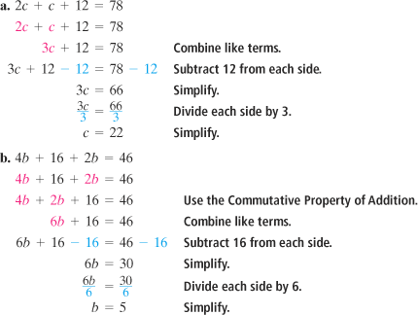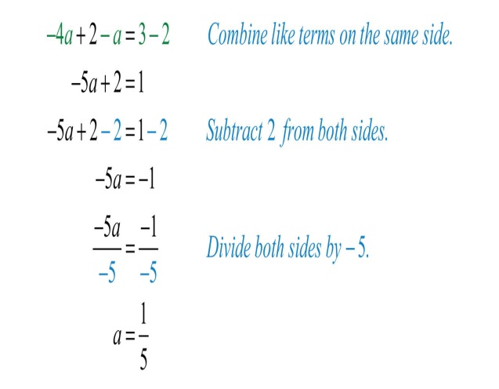

III. Solving Equations
- Specific Solution- the variable can be only one possible number
5x=25
x=5
- Infinite Solution- the variable can be any number and the equation will always be true
2(x-4) = 2x-8
2x-8 = 2x-8
- No Solution- No Value that we can plug in will make the equation true

VI. Perimeter Verses Area (2-D)

Shape (2-D) | Perimeter Formula | Area Formula
Square | P= S+S+S+S  P= 4S | A= L×W  A= S²
Rectangle | P= L+L+W+W  P= 2(L)+ 2(W) | A= L×W
Triangle | P= a+b+c  (Leg + Leg + Hypotenuse) | A= (BH)÷2

V. Volume of 3-D Objects

Shape (3-D) | Picture | Volume
Rectangular Prism | 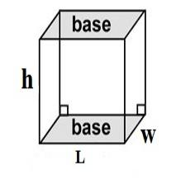 | V= l×w×h
Cylinder | 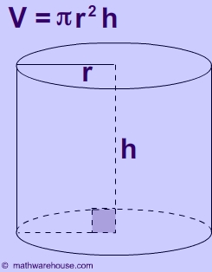 | V= πr²h
Cone |  | V=¹/₃ πr²h
Sphere | 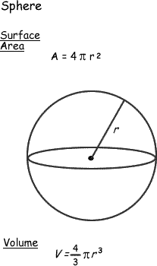 | V=⁴/₃ πr³
Triangular Prism | 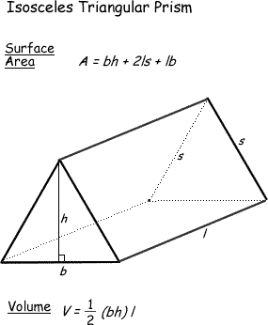 | V= (bh₁÷2)(h₂)
Pyramid | 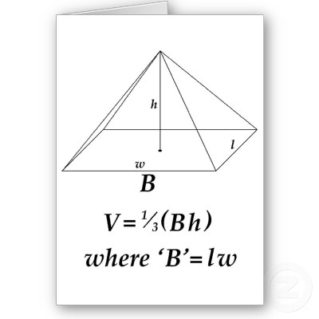 | V= ¹/₃ lwh

Section 10-Law of Exponents, Scientific Notation, and System of Equations
I. Laws of Exponents and Properties
- The exponent of a number says how many times to use the number (Base) in a multiplication.
Law or Properties | Definition/ What is it | Example
Product Law #1 | When multiplying terms with the same base but different exponents, you keep the base as it is and add the exponents. | (a)^{b} × (a)^{c} = a^{(b+c)}  (9)⁸ × (9)² = 9⁽⁸⁺²⁾ = 9¹⁰
Product Law #2 | When multiplying terms with the same exponent but different bases, you keep the exponents as it is and multiply the bases. | (a)^{c} × (b)^{c} = (a×b)^{c}  (6)³ × (5)³ = (6×5)³ = 30³
Quotient Law #1 | When dividing terms with the same bases but different exponents, you keep the base as it is and subtract the exponents. | (a)^{b} ÷ (a)^{c} = (a)^{(b-c)}  (9)⁸ ÷ (9)³ = (9)⁽⁸⁻³⁾ = 9⁵
Quotient Law #2 | When dividing terms with the same exponents but different bases, you divide the base and keep the exponents as it is. | (a)^{c} ÷ (b)^{c} = (a÷b)^{c}  (9)⁸ ÷ (3)⁸ = (9÷3)⁸ = 3⁸
Power to Power Law | When you raise a power to power exponent, you multiply the exponents | (a^{b})^{c} = (a)^{(b×c)}  (mx^{b})ª = (mª)(x^{ab})
Zero Power Law | Any value to the power of zero is ALWAYS equal to one. | (a)⁰ = 1
Negative Integer Exponents | When the exponent is a negative number, it is going to be one over the base number and the exponent is positive (denominator) | 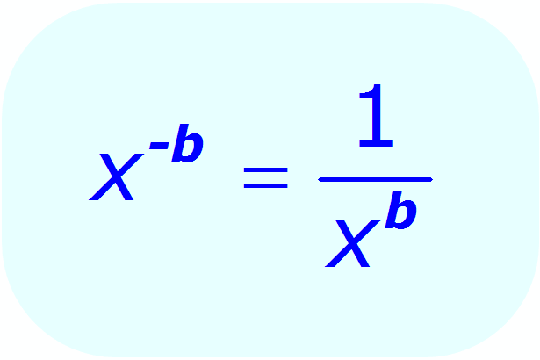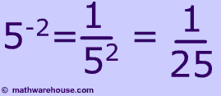
Identity Property | When the exponent is raised to the power of one, the base is equal to itself | (a)¹ = a  (5)¹ = 5

II. Scientific Notation
- A special way of writing numbers that makes it easier to use big and small numbers.
- Powers of 10 (Moves the decimal based on the exponent)
- If the exponent is positive, you move the decimal to the right. If the exponent is negative, you move the decimal to the right.
- The number MUST be 1 ≤ x < 10 (more than or equal to one or less than ten). If the number is higher than 10, you move the decimal to the left and add the amount of time you moved the decimal, to the exponent. If the number is lower than 1, you move the decimal to the right and subtract the amount of time you moved the decimal, to the exponent
- It’s basically like, if the number is bigger than 10, you divide by 10. If the number is lower than 1, and then you multiply by 10.

Scientific Notation | Standard Notation
3.05 × 10⁹ | 3,050,000,000
3.6 × 10⁻⁴ | 0.00036
9.99 × 10⁴ | 99,900
5.08 × 10⁻⁴ | 0.000508
8.001 × 10⁻¹⁰ | 0.0000000008001
3.508 × 10⁶ | 3,508,000
8.049 × 10¹² | 8,049,000,000,000
6.05 × 10⁹ | 6,050,000,000

III. Multiplying and Dividing Numbers using Scientific Notation
- Just like Product Law (Laws of Exponents) stated, when multiplying scientific notation, you multiply the first numbers and add the powers of 10.
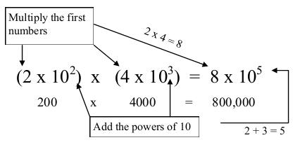
- Just like Quotient Law (Laws of Exponents) stated, when dividing scientific notation, you divide the first numbers and subtract the powers of 10.
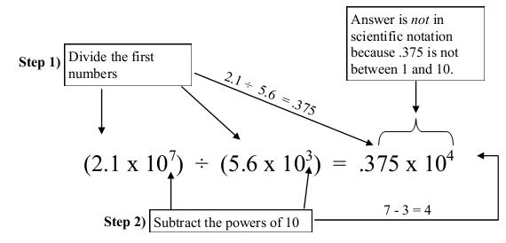
- WAIT! The number is less than one. So you move the decimal to the right once and subtract one to the exponent so the final solution will be (3.75 × 10³)
VI. Systems of Equation
- If you recall, the general slope-intercept form of a linear function is y = mx + b
- Systems of Equation is when you graph two or more linear functions “simultaneously” or at the same time.
- When two lines are graphed, the point of intersection is called the “solution” to the system. It`d the point that both functions have common.
- When two lines are graphed and they have the same slope, then there WILL NOT be a solution because both lines will be parallel

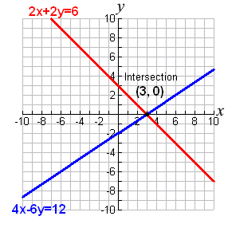  Solution is the intersection which is (3,0) | 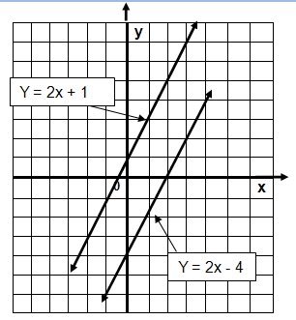  There is no solution because they are parallel and there is no intersection

V. Solving Systems of Equation
- When solving Systems of Equation, your goal is to find the value of x and y that satisfy both equations
Ways to Solve It | Step by Step | Example
Substitution | (1) Isolate one variable in one equation if necessary.  (2) Plug into the other equation, the equivalent expression to the first variable.  (3) Solve the Equation  (4) Use the first variable in one of the equations to find the other variable. | 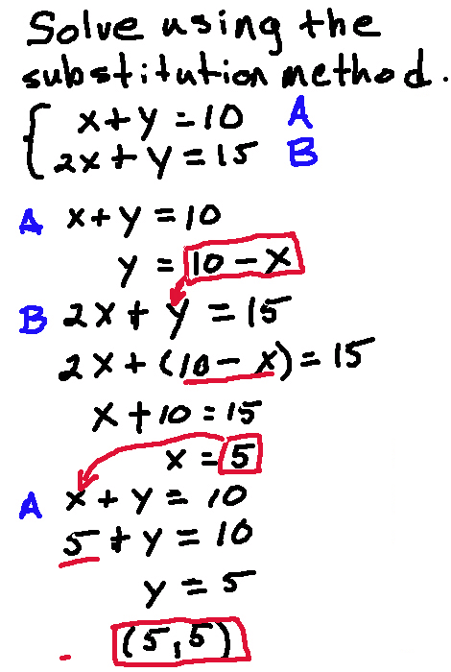
Elimination | (1) To get rid of one variable, you need to find the additive inverse of one coefficient. (Meaning that when a number is added or subtract to a given number, it gives you zero)  (2) Once you found the additive inverse, you put the equation where you found the additive inverse in parenthesis and put the number, that when the equation is distributed, the additive inverse number will cancel out the coefficient.  (3) Distribute the equation in parenthesis  (4) Solve the Equation  (5) Use the first variable in one of the equations to find the other variable | 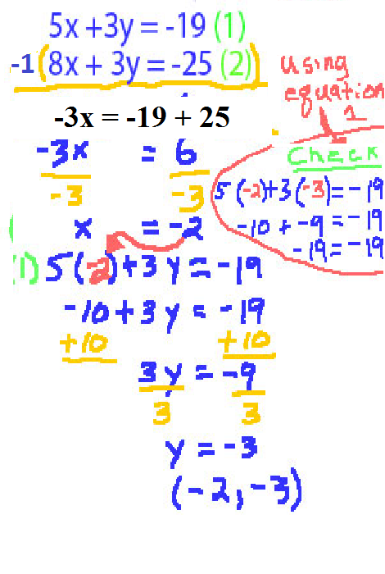
Graphically | (1) To change the equation into the general linear equation, you subtract the coefficient along with “x” on both sides. (IF NEEDED. If not, then just graph it)  (2) After you changed it into the general linear equation, you graph the two lines. | 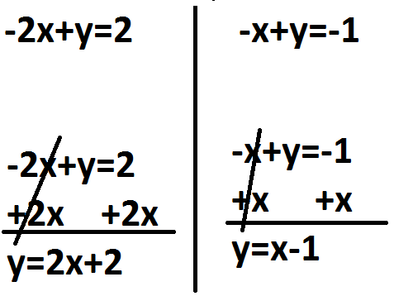  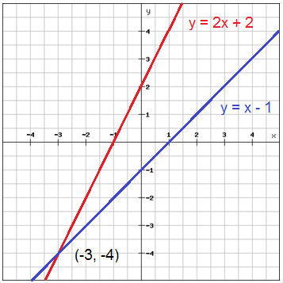

This State Test Review Packet took a very long time to complete. It felt endless. However, use it and study it! It`s a study tool for you to use for the State Test. I wish all of you the best. I BETTER NOT SEE ANYONE GOING TO SUMMER SCHOOL!
GOOD LUCK!
This is all I can do for you guys. The LONGEST and MOST ANNOYING Review Packet that I ever made. Hope it pays off. Anyway, good luck on the test. Hope you ALL PASS!
If you need extra help, you better start coming for tutorial. You will regret it if you don`t. This is a big test and it WILL impact your grade. You pass, that`s great. You fail…I can`t really help you anymore.
WARNING*- IF YOU FAIL THE STATE TEST, DON`T COME BLAMING ME, IT MEANS YOU DIDN`T STUDY HARD. DON`T SLACK OFF. THIS IS SERIOUS BUSINESS! YOU SLACK OFF, YOU MIGHT BE IN 8TH GRADE AGAIN! BETTER NOT FAIL!

Before the test comes, you should study! I don`t know what the test is going to be like. However, be prepare for it. It`s a three day test and I don`t want anyone to fail it. Hope this helps you pass this test. BEST OF LUCK! YOU PEOPLE BETTER NOT FAIL! Not only will it disappoint your teacher, it will also upset you (And don`t say I don`t care because you DO care!)

BEST WISHES AND BEST OF LUCK. (Well, you might not even need luck.)

Special Thanks
Mr. Frangella- Thank you for all the information. Your teaching was outstanding! It is you that helped me create this review packet. Hope all that hard work pays off and make sure everyone pass that test.
Mr. Silverman- Thank you for giving me the idea of making “Study Guides” In 6th grade, when the State exam was around the corner, you made everyone in class 612 make their own Study Guides and because of that, I have been making review packets ever since. Thanks a lot!
Manuel Wu Chen, Amy Lai, Da Hong Liu, Leonardo Cheng Huang, David Jiang, and Yiqing Hu (817 Math Mathematician)
THANK YOU EVERYONE!

