Law of Exponents, Scientific Notation, and System of Equations
I. Laws of Exponents and Properties
- The exponent of a number says how many times to use the number (Base) in a multiplication.
Law or Properties | Definition/ What is it | Example
Product Law #1 | When multiplying terms with the same base but different exponents, you keep the base as it is and add the exponents. | (a)^{b} × (a)^{c} = a^{(b+c)}  (9)⁸ × (9)² = 9⁽⁸⁺²⁾ = 9¹⁰
Product Law #2 | When multiplying terms with the same exponent but different bases, you keep the exponents as it is and multiply the bases. | (a)^{c} × (b)^{c} = (a×b)^{c}  (6)³ × (5)³ = (6×5)³ = 30³
Quotient Law #1 | When dividing terms with the same bases but different exponents, you keep the base as it is and subtract the exponents. | (a)^{b} ÷ (a)^{c} = (a)^{(b-c)}  (9)⁸ ÷ (9)³ = (9)⁽⁸⁻³⁾ = 9⁵
Quotient Law #2 | When dividing terms with the same exponents but different bases, you divide the base and keep the exponents as it is. | (a)^{c} ÷ (b)^{c} = (a÷b)^{c}  (9)⁸ ÷ (3)⁸ = (9÷3)⁸ = 3⁸
Power to Power Law | When you raise a power to power exponent, you multiply the exponents | (a^{b})^{c} = (a)^{(b×c)}  (mx^{b})ª = (mª)(x^{ab})
Zero Power Law | Any value to the power of zero is ALWAYS equal to one. | (a)⁰ = 1
Negative Integer Exponents | When the exponent is a negative number, it is going to be one over the base number and the exponent is positive (denominator) | 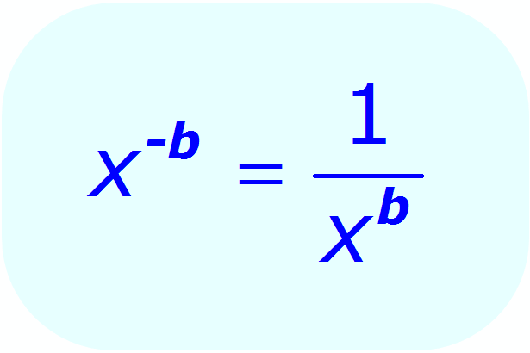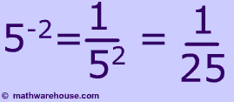
Identity Property | When the exponent is raised to the power of one, the base is equal to itself | (a)¹ = a  (5)¹ = 5

II. Scientific Notation
- A special way of writing numbers that makes it easier to use big and small numbers.
- Powers of 10 (Moves the decimal based on the exponent)
- If the exponent is positive, you move the decimal to the right. If the exponent is negative, you move the decimal to the right.
- The number MUST be 1 ≤ x < 10 (more than or equal to one or less than ten). If the number is higher than 10, you move the decimal to the left and add the amount of time you moved the decimal, to the exponent. If the number is lower than 1, you move the decimal to the right and subtract the amount of time you moved the decimal, to the exponent
- It’s basically like, if the number is bigger than 10, you divide by 10. If the number is lower than 1, and then you multiply by 10.

Scientific Notation | Standard Notation
3.05 × 10⁹ | 3,050,000,000
3.6 × 10⁻⁴ | 0.00036
9.99 × 10⁴ | 99,900
5.08 × 10⁻⁴ | 0.000508
8.001 × 10⁻¹⁰ | 0.0000000008001
3.508 × 10⁶ | 3,508,000
8.049 × 10¹² | 8,049,000,000,000
6.05 × 10⁹ | 6,050,000,000

III. Multiplying and Dividing Numbers using Scientific Notation
- Just like Product Law (Laws of Exponents) stated, when multiplying scientific notation, you multiply the first numbers and add the powers of 10.
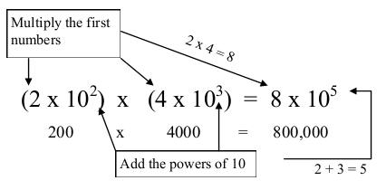
- Just like Quotient Law (Laws of Exponents) stated, when dividing scientific notation, you divide the first numbers and subtract the powers of 10.
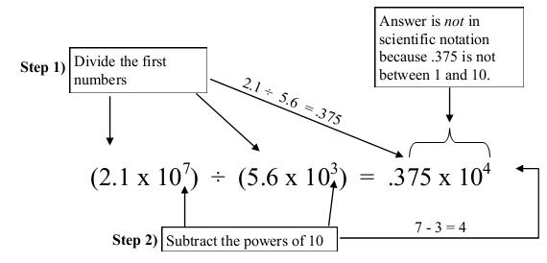
- WAIT! The number is less than one. So you move the decimal to the right once and subtract one to the exponent so the final solution will be (3.75 × 10³)
VI. Systems of Equation
- If you recall, the general slope-intercept form of a linear function is y = mx + b
- Systems of Equation is when you graph two or more linear functions “simultaneously” or at the same time.
- When two lines are graphed, the point of intersection is called the “solution” to the system. It`d the point that both functions have common.
- When two lines are graphed and they have the same slope, then there WILL NOT be a solution because both lines will be parallel

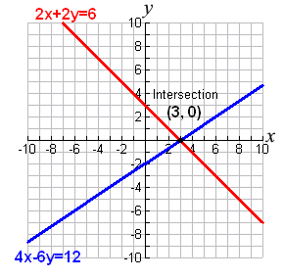  Solution is the intersection which is (3,0) | 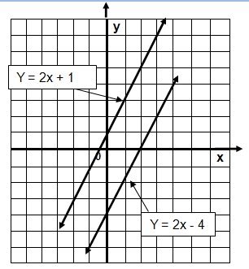  There is no solution because they are parallel and there is no intersection

V. Solving Systems of Equation
- When solving Systems of Equation, your goal is to find the value of x and y that satisfy both equations
Ways to Solve It | Step by Step | Example
Substitution | (1) Isolate one variable in one equation if necessary.  (2) Plug into the other equation, the equivalent expression to the first variable.  (3) Solve the Equation  (4) Use the first variable in one of the equations to find the other variable. | 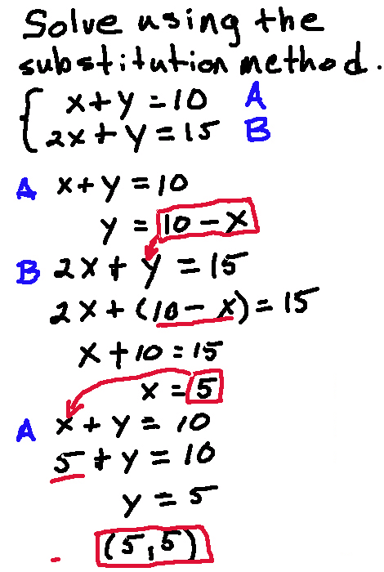
Elimination | (1) To get rid of one variable, you need to find the additive inverse of one coefficient. (Meaning that when a number is added or subtract to a given number, it gives you zero)  (2) Once you found the additive inverse, you put the equation where you found the additive inverse in parenthesis and put the number, that when the equation is distributed, the additive inverse number will cancel out the coefficient.  (3) Distribute the equation in parenthesis  (4) Solve the Equation  (5) Use the first variable in one of the equations to find the other variable | 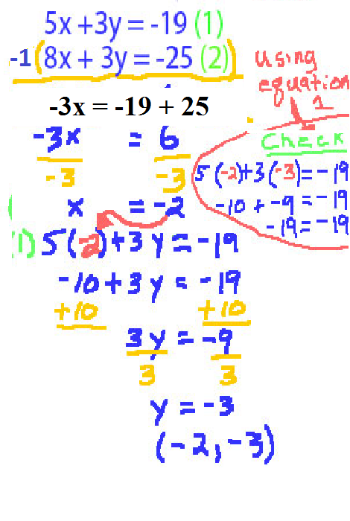
Graphically | (1) To change the equation into the general linear equation, you subtract the coefficient along with “x” on both sides. (IF NEEDED. If not, then just graph it)  (2) After you changed it into the general linear equation, you graph the two lines. | 