Review:
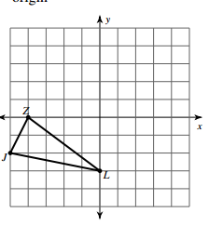
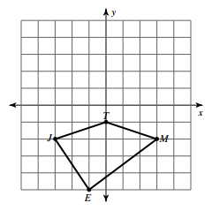
- Rotate the figure 180 degrees 2. Reflect over the line y = -x

3. Solve for n: 4(n – 10) = 2n + 30

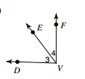
- Given the picture to the left, m<3 = (4x + 10) and m<4 = (x + 15)
- What is the relationship between angles 3 and 4?
- Set up an equation based on the relationship in the picture.
- Solve the equation to find the value of x.
- Evaluate the expression for angle 3 with the solution from part c to find the measure of angle c in degrees.
- Challenge: Find the value of x.
