Review:
- Add: $3\frac{4}{5} + \frac{1}{3}$
- Find 55% of 90 using a ratio table.
For the following questions, name the given angle in the picture:  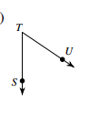 | 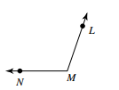 | 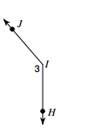
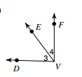
- In the picture to the left, angles < DEF and <EVF are complementary.
- What is another name for angle 3? __________
- What does “complementary” mean?
- If the measure of angle <EVF is 40 degrees, what is the measure of angle <DEF?
- Explain how you got your answer in part C.
For each question below, find the missing angle measure b in the picture:
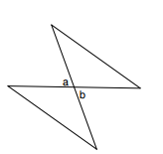
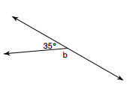
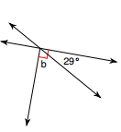
- m<a = 67 8. 9.
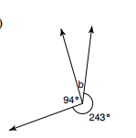
10. Challenge: a) What is the measure of angle b?
b) Explain how you got your answer. Use at least 3 sentences.

